

DPWWRNW – THE PAYMENT SYSTEM CBP WORKFLOWS

CONTRACT NO: PWR 107/22
DESCRIPTION: PROJECT, PROGRAMME AND PORTFOLIO MANAGEMENT TO PROJECT, PROGRAMME AND PORTFOLIO MANAGEMENT (PPPM) SERVICES FOR THE NORTH WEST DEPARTMENT OF PUBLIC WORKS AND ROADS FOR A PERIOD OF THIRTY-SIX (36) MONTHS

DOCUMENT CONTROL SHEET
The purpose of this form is to ensure that documents are reviewed and approved prior to issue. The form is to be bound into the front of all documents issued by GO BENG DBG PROJECTS (PTY) LTD JOINT VENTURE
DOCUMENT PROPERTIES
Item | Description
Document Title | DPWWRNW – THE PAYMENT SYSTEM CBP WORKFLOWS
Client | NORTH WEST PUBLIC WORKS AND ROADS
Consultant | GO BENG CONSULTING - DBG PROJECTS (PTY) LTD JOINT VENTURE
Document Status | FINAL REPORT
Date
VERSION CONTROL
Version | Prepared By | Signature
FIRST DRAFT | Stefan van Tonder
Version | Reviewed By | Signature
FIRST REVIEW | Nelisiwe Mnyazana
Version | Approved By | Signature
SECOND REVIEW
APPROVED FOR EXTERNAL ISSUE BY
Version | Approved By | Signature
FINAL REPORT | Phumza Smith

TABLE OF CONTENTS
1. WORKFLOW 1: CBP Participant Registration 5
Purpose 5
Trigger 5
Main Roles 5
Special Fields 5
Workflow Stages 6
Workflow Rules 7
2. WORKFLOW 2: CBP Participant Record Quality Assurance 7
Purpose 7
Ensure participant records are accurate, complete, audit-ready, and compliant for reporting 7
Trigger 7
Main Roles 7
Special Fields 7
Workflow Stages 8
Workflow Rules 8
Notifications 9
3. WORKFLOW 3: Participant – Time and Attendance 9
Purpose 9
Trigger 9
Main Roles 9
Special Fields 9
Workflow Stages 10
Workflow Rules 11
Notifications 11
4. WORKFLOW 4: Stipend Payment Approval 11
Purpose 11
Trigger 11
Approved attendance period closed and payroll cycle opened 11
Main Roles 11
Special Fields 12
Workflow Stages 13
Workflow Rules 13
Notifications 13
5. WORKFLOW 4: CBP Participant Verification 14
Purpose 14
Trigger 14
Main Roles 14
Special Fields 14
Workflow Stages 15
Workflow Rules 15
Notifications 15
6. Shared Master Status List 15
7. Recommended Dashboards 16
Participant Operations 16
Attendance Dashboard 16
Payment Dashboard 16
Compliance Dashboard 16

Phase one Implementation

WORKFLOW 1: CBP Participant Registration

Purpose
Capture new participant applications, validate completeness, and route for enrolment approval.

Trigger
New participant application submitted by official / field officer / data capture.

Main Roles
- Social Facilitator
- Data Capturer
- Supervisor
- Programme Manager
- QA Officer

Special Fields
Each of the following steps will require its own special fields which are mandatory to be populated by the main roles.
Step 1 - Personal Details
- First Name
- Last Name
- ID Number
- Date of Birth
- Gender
- Disability Status
- Contact Number
Step 2 - Address Details
- Province
- District
- Ward
- Physical Address
Step 3 -Programme Fields [Next phase]
- Programme Type (EPWP Indirect/ CBP - Direct)
- Intake Batch
- Target Group
- Work Opportunity Type
- Site / Project Allocation
Step 4 - Eligibility Fields [Next phase]
- Age Valid
- SA Citizen
- Unemployed
- Duplicate Check Result
- Eligibility Result
Step 5 Banking Fields
- Bank Name
- Account Holder
- Account Number Masked
- Branch Code
- Bank Verification Status
Step 6 – Supporting Documents
- ID Copy
- Proof of Address
- Consent Form
- Bank Confirmation
- CV (optional)
Step 7 – QA and Approval
- Recommended Outcome
- Approval Outcome
- Rejection Reason
- Return Reason
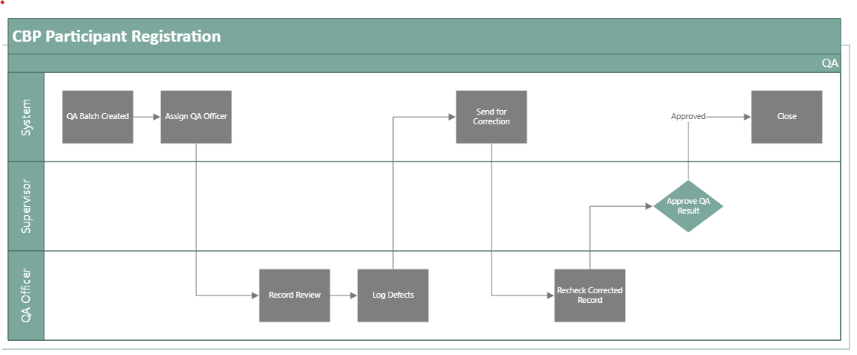

Workflow Stages
Draft Capture
↓
Submit Registration
↓
Completeness Check
↓
Eligibility Verification
↓
Banking Verification
↓
Supervisor Review
↓
Approve / Reject
↓
Create Participant Record
↓
Notify Stakeholders
↓
Close

Workflow Rules
- Mandatory fields required before submit
- Invalid ID number = reject
- Duplicate ID found = route to verification hold
- Missing documents = return for correction
- Approved = auto-create Participant ID
- Rejected = mandatory reason

WORKFLOW 2: CBP Participant Record Quality Assurance

Purpose

Ensure participant records are accurate, complete, audit-ready, and compliant for reporting

Trigger
Periodic QA cycle / pre-payment review / audit preparation / manager request.

Main Roles
- Social Facilitator
- QA Officer
- Data Steward
- Supervisor
- Programme Manager
- Internal Audit (read-only)

Special Fields
Each of the following steps will require its own special fields.
Step 1 -QA Control
- QA Case ID
- Participant ID
- QA Batch
- Review Date
- Reviewer
Step 2 -Data Quality Checks
- Mandatory Fields Complete
- Valid ID Format
- Duplicate Record Check
- Contact Info Complete
- Supporting Docs Present
- Status Accurate
- Site Allocation Valid
- Banking Info Complete
Step 3 - Scoring
- QA Score (%)
- Error Count
- Critical Errors
- Minor Errors
Step 4 – Remediation
- Correction Required
- Assigned Corrector
- Correction Due Date
- Corrective Action Notes
Step 5 – Final Outcome
- Passed QA
- Passed with Corrections
- Failed QA
- Escalated

Process Flow Participant Record Quality Assurance

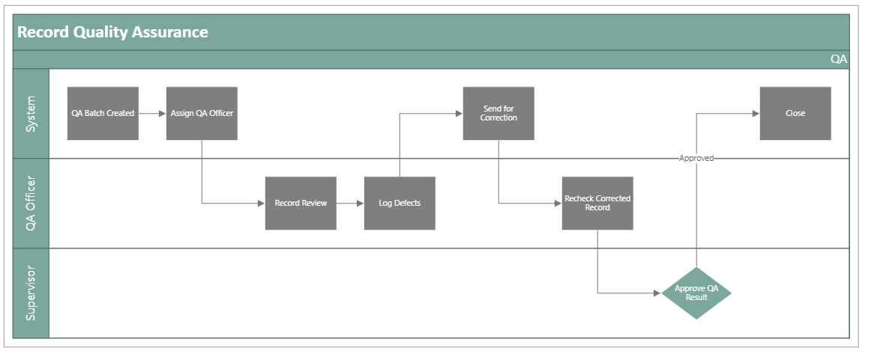

Workflow Stages
QA Batch Created
↓
Assign QA Officer
↓
Record Review
↓
Log Defects
↓
Send for Correction
↓
Recheck Corrected Record
↓
Approve QA Result
↓
Close & Report

Workflow Rules
- Missing ID = critical fail
- Duplicate participant = critical fail
- Missing banking info = payment hold
- Score below threshold = fail
- Corrections overdue = escalate
- All defects cleared = pass

Notifications
- QA assigned
- Corrections requested
- Overdue correction
- QA passed
- QA failed

Phase Two Implementation

WORKFLOW 3: Participant – Time and Attendance

Purpose
Capture, validate, approve, and report participant attendance for work performed, training attended, or programme participation days.

Trigger
Daily attendance capture / weekly submission / monthly attendance close-off

Main Roles
- Social Facilitator
- Site Supervisor
- Field Officer
- Data Capturer
- Verifier
- Programme Manager
- Payroll Officer

Special Fields
Each of the following steps will require its own special fields.
Step 1 - Attendance Control
- Attendance Record ID
- Participant ID
- Attendance Period
- Attendance Date
- Site / Project
- Supervisor
Step 2 - Attendance Detail
- Check-In Time
- Check-Out Time
- Hours Worked
- Attendance Status (Present / Absent / Late / Half Day / Leave / Training / Suspended)
- Work Type
Step 3 - Validation Fields
- Duplicate Attendance Check
- Participant Active Status
- Site Allocation Valid
- Approved Days Count
- Overtime Hours (if applicable)
Step 4 - Evidence Fields
- Attendance Captured
- GPS Confirmed
- Biometric Confirmed (optional future)
- Photo Evidence
- Supervisor Comments
Step 5 - Decision Fields
- Submitted By
- Verified By
- Approved By
- Rejection Reason
- Return Reason
Step 6 - Integration Fields
- Payroll Eligible Days
- Export Batch ID
- Locked for Payroll (Yes/No)

Process Flow Participant – Time and Attendance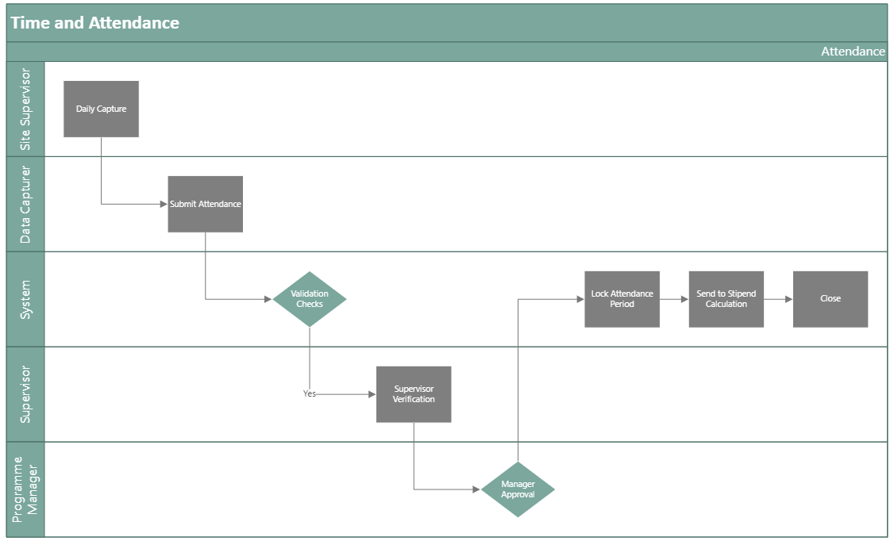

Workflow Stages
Daily Capture
↓
Submit Attendance
↓
Validation Checks
↓
Supervisor Verification
↓
Manager Approval
↓
Lock Attendance Period
↓
Send to Stipend Calculation
↓
Close

Workflow Rules
- Inactive participant cannot be marked present
- Duplicate same-day attendance blocked
- Missing supervisor evidence = return
- Attendance after cut-off requires override reason
- Approved records locked from editing
- Locked records become available for stipend processing

Notifications
- Attendance submitted
- Attendance returned
- Attendance approved
- Attendance period locked
- Exceptions flagged

WORKFLOW 4: Stipend Payment Approval

Purpose
Calculate stipend due, route for approval, and confirm approved records are eligible for inclusion in the SAGE payment file.

Trigger

Approved attendance period closed and payroll cycle opened

Main Roles
- Social Facilitator
- Site Supervisor
- Field Officer
- Data Capturer
- Verifier
- Programme Manager
- Payroll Officer

Special Fields
Each of the following steps will require its own special fields.
Step 1 - Payment Control
- Payment Batch ID
- Payroll Period
- Payment Run Date
- Participant ID
- Linked Attendance Batch
Step 2 - Calculation Fields
- Approved Days Worked
- Daily Rate
- Gross Stipend
- Deductions
- Net Pay
- Funding Source
- Cost Centre
Step 3 - Banking Fields
- Bank Name
- Account Holder
- Account Number Masked
- Branch Code
- Bank Verification Status
Step 4 - Validation Fields
- Attendance Approved
- Participant Active
- Banking Complete
- Duplicate Payment Check
- Budget Available
- Exception Flag
Step 5 - Approval Fields
- Prepared By
- Checked By
- Approved By
- Approval Date
- Rejected By
- Rejection Reason
Step 6 - SAGE Export Field
- SAGE Export Status
- Export File Number
- Export Date
- Payment Reference
- Posted to SAGE (Yes/No)

Process Flow Stipend Payment Approval
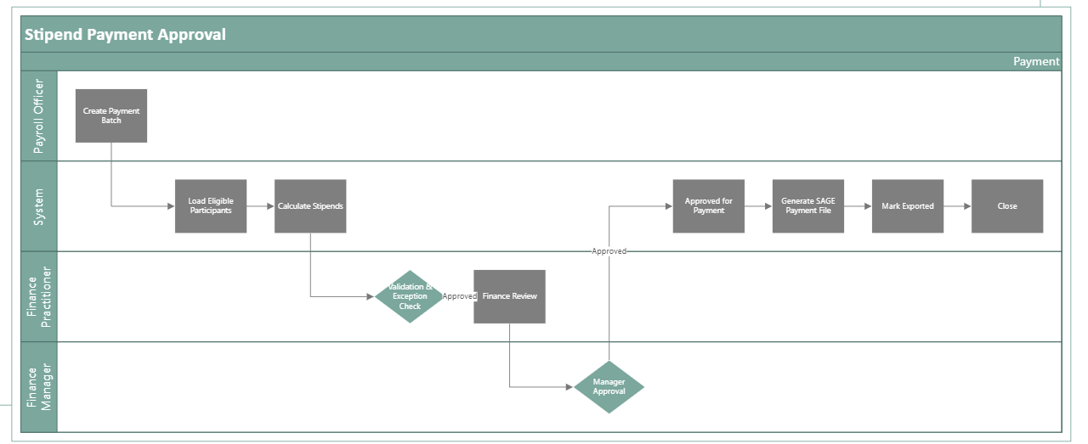

Workflow Stages
Create Payment Batch
↓
Load Eligible Participants
↓
Calculate Stipends
↓
Validation & Exception Check
↓
Finance Review
↓
Manager Approval
↓
Approved for Payment
↓
Generate SAGE Payment File
↓
Mark Exported
↓
Close

Workflow Rules
- Only approved attendance may be paid
- Missing bank details = exclude from batch
- Duplicate payment in same period blocked
- Negative net pay blocked
- Batch cannot export without approval
- Once exported, records locked
- Rejected records returned for correction
- Approved status = valid for SAGE file inclusion

Notifications
- Batch created
- Exceptions found
- Batch submitted for approval
- Payment approved
- Payment rejected
- SAGE file generated
- Export completed

WORKFLOW 4: CBP Participant Verification

Purpose
Verify that registered participants are legitimate, active, and compliant before placement/payment/reporting.

Trigger
Approved registration OR scheduled re-verification OR exception flag

Main Roles
- Social Facilitator
- Verification Officer
- Field Officer
- Supervisor
- Programme Manage

Special Fields
Each of the following steps will require its own special fields.
Step 1 - Verification Control
- Verification ID
- Linked Participant ID
- Verification Type (Initial / Reverification / Exception)
- Verification Date
- Verification Status
Step 2 - Identity Checks
- ID Confirmed
- Home Affairs Match (optional future)
- Duplicate Match
- Deceased Check (optional future)
Step 3 - Eligibility Checks
- Employment Status Confirmed
- Age Category Confirmed
- Residency Confirmed
- Target Group Confirmed
Step 4 - Attendance / Presence
- Site Visit Completed
- Present on Site
- Supervisor Confirmed
Step 5 - Attendance / Presence
- Photo Captured
- GPS Captured
- Supporting Notes
- Attachments
Step 6 - Attendance / Presence
- Verified Pass
- Verified Fail
- Escalate
- Reason Code

Process Flow Participant Verification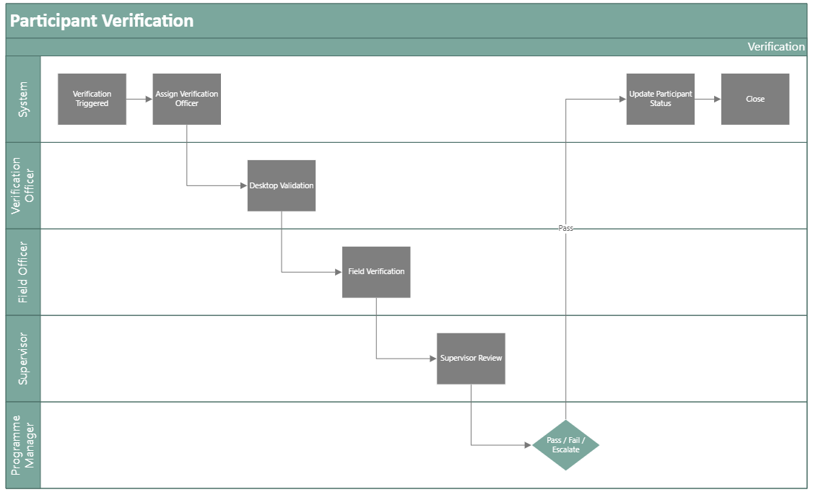

Workflow Stages
Verification Triggered
↓
Assign Verification Officer
↓
Desktop Validation
↓
Field Verification (if required)
↓
Supervisor Review
↓
Pass / Fail / Escalate
↓
Update Participant Status
↓
Close

Workflow Rules
- Failed ID validation = immediate escalation
- No show on site = fail pending investigation
- Missing evidence = return to verifier
- Pass = participant remains active
- Fail = suspend participant
- Escalated = manager review mandatory

Notifications
- Verification assigned
- Participant flagged
- Verification passed
- Verification failed
- Escalation notice

Shared Master Status List
Use common statuses across all workflows:

- Draft
- Submitted
- In Review
- Pending Verification
- Pending Approval
- Approved
- Rejected
- Returned for Correction
- Escalated
- Locked
- Exported
- Closed

Recommended Dashboards

Participant Operations
- Active participants by Programme Group / District
- New registrations by month / Programme Group / District
- Verification pass/fail rates / Programme Group / District
- QA defect trends

Attendance Dashboard
- Present vs absent by site / Programme Group / District
- Attendance approval backlog
- Late submissions
- Monthly worked days totals

Payment Dashboard
- Batches pending approval
- Total stipends approved
- Excluded participants with reasons
- SAGE exports completed
- Payment cycle turnaround time

Compliance Dashboard
- Duplicate records flagged
- Missing documents
- Overdue workflow items
- Audit exceptions by district

